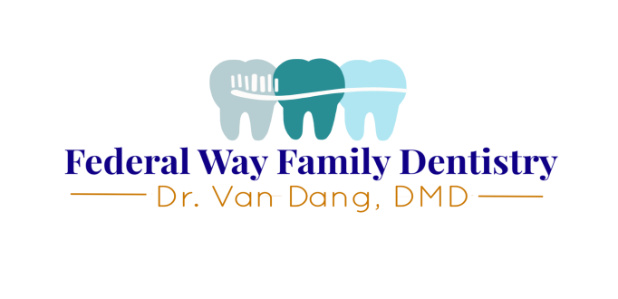

Patient Registration

**PATIENT NAME**________________________________ I prefer to be called: _______________________

I prefer to be contacted by (mark one choice): [ ]1. Email [ ]2.Text Message [ ]3. Phone call

Gender: M F Date of Birth _______________ Age _______ Social Security # ________________

Home # _________________ Work # _________________ Cell # _________________

Email address ____________________________________ Address_____________________________________ City, State _______________________Zip_________

Marital status: ________ Employer __________________________ Occupation______________________

Whom may we thank for referring you? _______________________________________________________

Other family members seen by us:____________________________________________________________

Spouse’s name:_____________________________ Date of Birth__________________

Person financially responsible for this account: __________________________________________

With whom may we discuss dental treatment and billing obligations? _________________________________

**PRIMARY INSURANCE**

Insurance Company______________________________ Phone #___________________

Subscriber’s name______________________________ Patient relation to subscriber____________________

Subscriber’s date of birth____________ Subscriber’s Social Sec # ______________

ID #_______________________ Subscriber’s employer_______________________________

**SECONDARY INSURANCE**

Insurance Company______________________________ Phone #___________________

Subscriber’s name______________________________ Patient relation to subscriber____________________

Subscriber’s date of birth____________ Subscriber’s Social Sec # ______________

ID #_______________________ Subscriber’s employer_______________________________

**EMERGENCY CONTACT**

Name______________________ Phone #__________________ Relation to patient____________________

I understand that this information is correct to the best of my knowledge. I also understand that this

information will be held in the strictest confidence and it is my responsibility to inform this office of any

changes in my medical status.

**_____________________________________________________ _______________________________**

Signature Date



**Medical History**

Although dental personnel primarily treat the area in and around your mouth, your mouth is a part of your entire body. Health problems that you may have, or medication that you may be taking, could have an important interrelationship with the dentistry you will receive. Thank you for answering the following questions.

Are you under a physician’s care no? Yes No If yes, why?_____________________________________

Have you ever been hospitalized or had a major operation? If yes, why?_________________________

Have you ever had a serious head or neck injury? Yes No If yes, why?_________________________

Are you taking any medications, pills or drugs? Yes No If so, please list: ________________________________________________________________________________________________________________________________________________________________________________________________________________________________________________________________________

Do you take, or have you taken Phen-Fen or Redux? Yes No

Have you ever taken Fosamax, Boniva, Actonel or any medications containing bisphosphonates? Yes No

Are you on a special diet? Yes No If so, explain__________________________________________

Do you use tobacco? Yes No Do you use controlled substances? Yes No

Women: Are you Pregnant? Yes No Nursing? Yes No Taking oral contraceptives? Yes No

Are you allergic to any of the following? Aspirin Penicillin Codeine Acrylic Latex Sulfa Drugs

Local Anesthetics Other: _______________________________

Please circle any of the following conditions you have or have had:

|  |  |  |  |
| --- | --- | --- | --- |
| AIDS/HIV Positive | Cortisone Medicine | Hemophilia | Radiation Treatments |
| Alzheimer’s Disease | Diabetes | Hepatitis A | Recent Weight Loss |
| Anaphylaxis | Drug Addiction | Hepatitis B or C | Renal Dialysis |
| Anemia | Easily Winded | Herpes | Rheumatic Fever |
| Angina | Emphysema | High Blood Pressure | Rheumatism |
| Arthritis/Gout | Epilepsy or Seizures | High Cholesterol | Scarlet Fever |
| Artificial Heart Valve | Excessive Bleeding | Hives or Rash | Shingles |
| Artificial Joint | Excessive Thirst | Hypoglycemia | Sickle Cell Disease |
| Asthma | Fainting Spells/Dizziness | Irregular Heartbeat | Sinus Trouble |
| Blood Disease | Frequent Cough | Kidney Problems | Spina Bifida |
| Blood Transfusion | Frequent Diarrhea | Leukemia | Stomach/Intestinal Dis. |
| Breathing Problems | Frequent Headaches | Liver Disease | Stroke |
| Bruise Easily | Genital Herpes | Low Blood Pressure | Swelling of Limbs |
| Cancer | Glaucoma | Lung Disease | Thyroid Disease |
| Chemotherapy | Hay Fever | Mitral Valve Prolapse | Tonsillitis |
| Chest Pains | Heart Attack/Failure | Osteoporosis | Tuberculosis |
| Cold Sores/Fever Blisters | Heart Murmur | Pain in Jaw Joints | Tumors or Growths |
| Congenital Heart Disorder | Heart Pacemaker | Parathyroid Disease | Ulcers |
| Convulsions | Heart Trouble/Disease | Psychiatric Care | Venereal Disease |
| Yellow Jaundice |  |  |  |

Have you ever had a serious illness not listed above? Yes No If yes, explain________________________

**Dental History**

General Dentist_____________________________________ Date of last visit___________________

What concerns you most about your teeth?__________________________________________________

Yes No Are you presently in any dental pain?________________________________________________________

Yes No Have you ever experienced any unfavorable reaction to dentistry? _________________________________

Yes No Is there any part of your mouth that is sensitive to temperature or pressure?__________________________

Where?_____________________________________________

Yes No Have you ever lost or chipped any teeth?______________________________________________________

Yes No Have there been any injuries to face, mouth or teeth?____________________________________________

Yes No Do your gums bleed when you brush?________________________________________________________

Yes No Do you have any type of thumb or tongue habits?_______________________________________________

Yes No Are you a mouth breather?________________________________________________________

Yes No Have you ever seen an orthodontist? If yes, who and when ?____________________________________

Yes No Do your teeth or jaws ever feel uncomfortable when you awake in the morning?______________________

Yes No Are you aware of your jaw clicking or popping?________________________________________________

Yes No Are you aware of clenching your teeth during the day?___________________________________________

Yes No Have you ever been told that you grind your teeth?______________________________________________

Yes No Do you have tension headaches?____________________________________________________________

Yes No Have you ever experienced chronic ringing in your ears?_________________________________________

Signature_______________________________________________ Date__________________________________

Dr. Van Dang, DMD

1025 S 320th, Suite 201

Federal Way WA 98003

Phone: 253-839-4636

Fax: 253-946-8286

**REQUEST FOR RECORDS RELEASE**

I, ___________, hereby request and give my permission to provide dental records of the following family members.

Please send my/our records to: ______________________

At the following address: ______________________________

_______________

I/We are transferring our records for the following reason/s. (please circle or explain)

1. Change of insurance, office is no longer on my plan.
2. Moving out of area/state.
3. Closer to home/work.
4. Other (please explain) _________________________________­­­­­­­­­____________

___________________________________________________________________________________________________________________________________

This authorization ends:

* In 90 days from the date signed
* On (date)_________________
* When the following event occurs:_____________________________

Signed: ____________ Date: ________

Home phone: ___________ Work phone: ___________

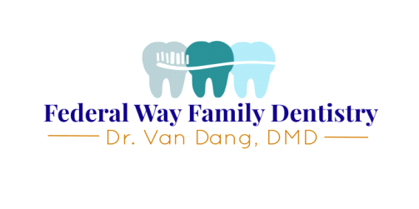

**Financial and Cancellation Policies**

**Dental Insurance:** We are not required by law to file insurance claims or make estimates of copays for patients. This is something we do as a courtesy for our patients. Please understand that insurance filing can be a sometimes lengthy process, and that any estimates of copays and coverage are not guaranteed. It is ultimately the patient’s responsibility to work with and understand their insurance policy’s benefits and terms. It is also the patient’s responsibility to report any insurance changes to us.

**By signing this agreement I understand that the office of Dr. Van Dang, DMD is not responsible for non-payment of benefits by my insurance company due to terms and clauses of my policy or denials. I, as a patient or responsible party, am fully responsible for all charges incurred whether I have insurance or not.**

**For Patients without Dental Insurance:** Please ask us about our Wellness Plan.

**Payments, Payment Plans, and Financing Options:** All balances are due within 30 days of service. Please make arrangements with us if you are unable to pay your balance within 30 days; occasionally we approve payment plans with established patients. We also accept Care Credit in our office. Referral to a collections company is sometimes necessary if you have made no response to statements or attempts to contact you regarding your balance.

For your convenience we accept cash, check, money order, Visa, Mastercard, Discover, American Express, HSA/FSA, and Care Credit.

**Cancellations:** As a private office, we are able to maintain a high standard of care and focus on each patient’s individual needs. Because we are privately owned by Dr. Dang, each unit of time on our schedule is very important.

**Appointment Confirmations are now required.** We offer many methods to confirm your appointment. We can send automated text messages to your cell phone to which you reply YES to confirm. If you do not have a cell phone we will call your home phone. If we have called and left you a voicemail, please call us back to confirm in a timely manner.

**If you have a scheduled appointment, but we are unable to reach you for positive confirmation, the appointment may be subject to cancellation.**

We understand that life happens, and we try to be as understanding as possible whenever a reserved appointment time needs to be cancelled. We ask that you give us as much notice as possible (preferably 48 hours in advance). The sooner you are able to let us know you cannot make it, the easier it is for us to give that appointment time to another patient who may be waiting for an opening. **For last-minute or recurring cancellations and no-shows, a $75 cancellation fee may be applied to your account.**

**Thank you for your careful review of this form. We look forward to our continuing relationship with you. Please sign below to acknowledge your understanding of this form. Refer to staff with any questions.**

**Print name: Signature: Date: / /**

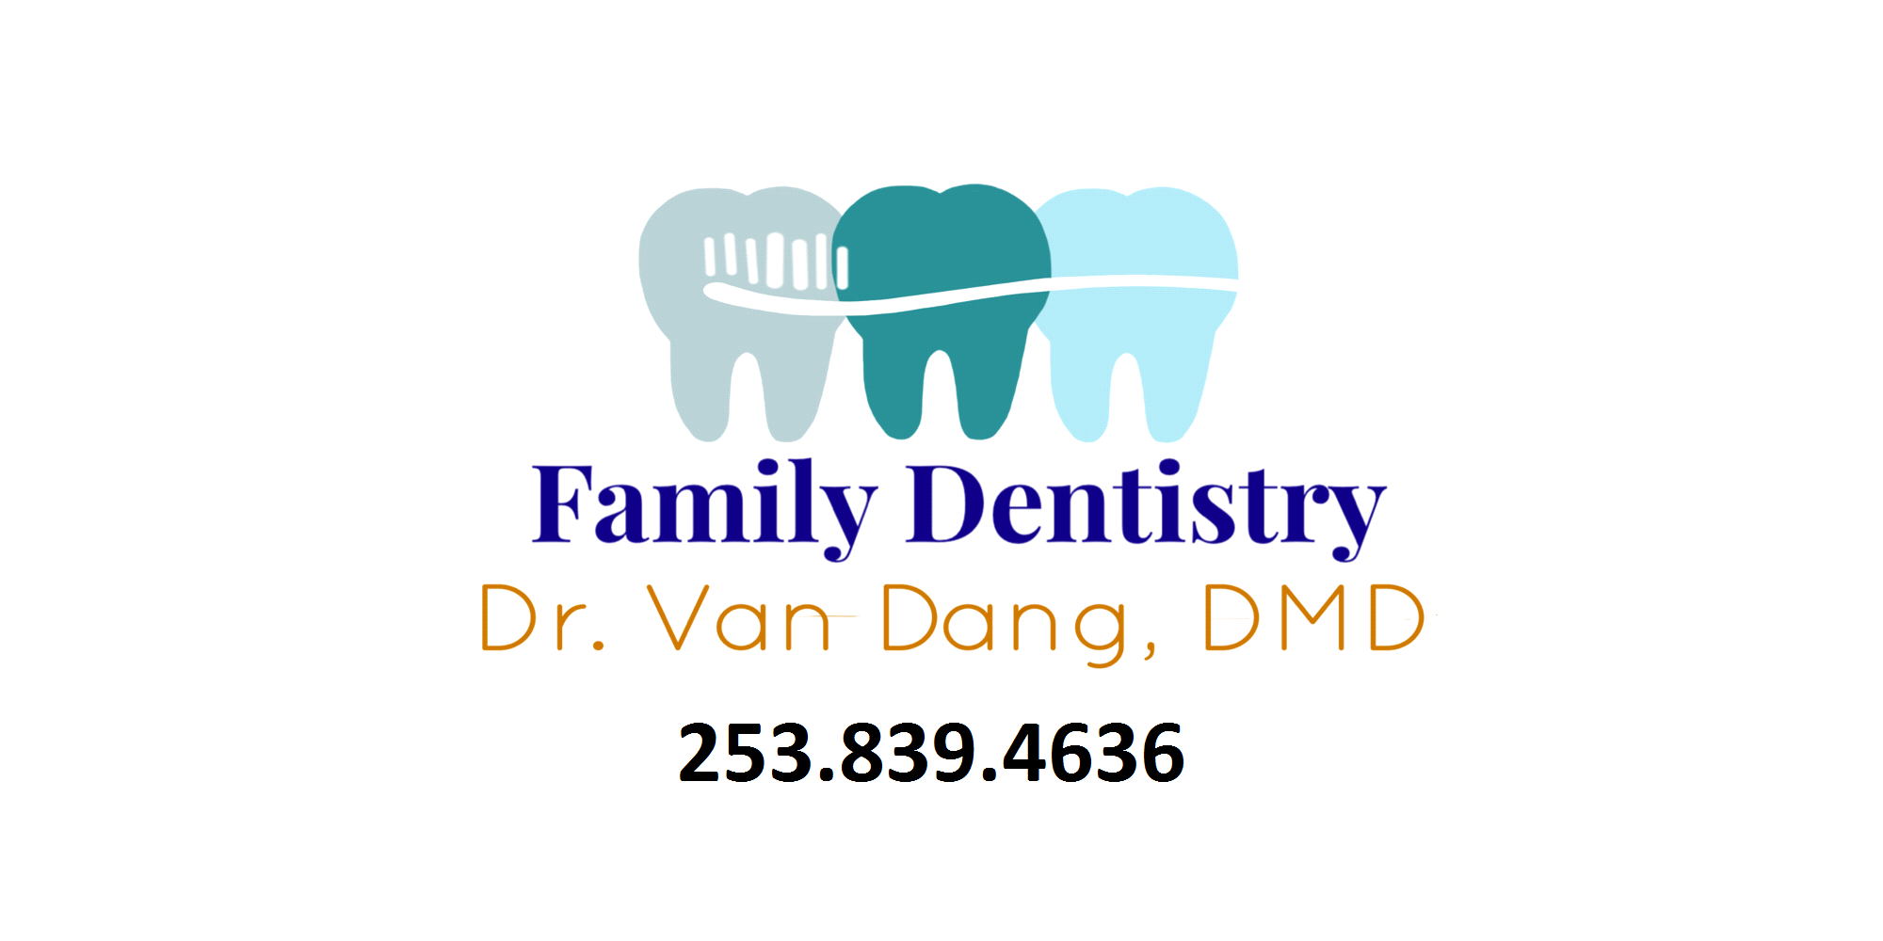

**Acknowledgement That You Have Received Our HIPAA Privacy Notice**

Federal Way Family Dentistry is required by law to keep your health information and records safe.

This information may include:

* Notes from your doctor, teacher or other healthcare provider
* Medical history
* Test results
* Treatment notes
* Insurance information

We are required by law to give you a copy of our privacy notice. This notice tells you how your health information maybe used and shared. This notice is available to be viewed anytime at the front desk.

☐ I acknowledge that I have received a copy of [Private Practice / Private Practitioner Name’s] HIPAA Notice of Privacy Practices that fully explains the uses and disclosures they will make with respect to my individually identifiable health information.

☐ I have had the opportunity to read the notice and to have any questions regarding the notice answered to my satisfaction.

☐ I understand [Private Practice / Private Practitioner Name] cannot disclose my health information other than as specified in the notice.

☐ I understand that [Private Practice / Private Practitioner Name] reserves the right to change the notice and the practices detailed therein if it sends a copy of the revised notice to the address I have provided.

_____________________________ _____________________

Print Name of Client Date

_____________________________ _____________________

Signature of Client or Legal Representative Relationship to Client